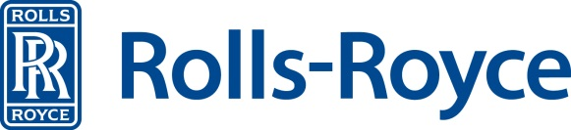

Product Certification: Country of Origin & NAFTA

Dear Supplier

Rolls-Royce is obligated by law to maintain documentation to substantiate the country of origin for all products and parts thereof. In order to meet this obligation it is requested that the supplier provide a country of origin affidavit and/or a NAFTA Certificate of Origin (as applicable) in the form of a blanket certificate for goods deliverable in the upcoming calendar year. This request is being made in accordance with the purchase order terms and conditions accepted by the Supplier.

Please complete the applicable form(s) for all goods (by Rolls-Royce part number) which will be provided during the upcoming calendar year and return them to Rolls-Royce at RRUSCOO@Rolls-Royce.com prior to shipment to, or on behalf of, Rolls-Royce.

Changes to the country of origin or subsequent agreement(s) to provide additional part numbers not included in the initial response require the provision of supplemental form(s). Supplemental forms should contain data only for the changed or added part number(s).

Forms are available on the internet at https://suppliers.rolls-royce.com/ on the “Supplier documents” page under the “Terms of business” section. Form(s) must be signed by an officer or other authorized representative of the supplier’s company.

Please note: The country of origin is the country where the item was manufactured or last underwent a substantial transformation and is not necessarily the country the item was exported or shipped from, nor where the supplier’s headquarters are located.

Suppliers are encouraged to consult with a Customs Broker, Legal Counsel or other advisor due to the complexity of customs and other applicable laws and also to ensure that form(s) provided are accurate and complete. Additional information can be found at the United States Customs & Border Protection website at: http://www.cbp.gov/ .

Your cooperation with this request is greatly appreciated.

Sincerely,

Rolls-Royce North America
PO Box 420
Mail Code: MC-N5-08
Indianapolis, IN 46206-0420
Phone (317) 230-6040
E-mail RRUSCOO@Rolls-Royce.com

Rev 12/2013-1

