Rolls-Royce Contractor and Strategic Supplier Travel and Expense Guidelines

TRAVEL
The Amex GBT / Rolls-Royce Travel Service may be used by our Suppliers and contractors (including Consultants and Secondees) only in respect of business activity associated with Rolls-Royce. Any travel bookings relating to non-Rolls-Royce business must not be booked via Amex GBT. Whilst booking via Amex GBT will allow access to Rolls-Royce preferential negotiated rates (air/hotel/car/airport transfers), the primary duty of care rests with their employer, both in terms of preparing travellers for the trip and assisting them if anything goes wrong. All reservations will need to be paid for using an individual credit card and suitable travel insurance will need to be provided by their employer.
For clarity there are 2 categories of contractor which have different requirements in terms of bookings:
Category 1 – Contractor who is on a fixed term contract with Rolls-Royce and has an Employee ID and loaded into Workday. These contractors have been set up with access to book via Concur Travel – go into your profile and add in your credit card details, nationality and passport information, for more complex travel please ring Amex GBT. Expenses should be managed via your Contract Agency (e.g., AMS).
Category 2 – Other contractors/visitors or suppliers. These travellers will need to create a profile in the Amex GBT system prior to making a reservation – details on how to do this are provided on Page 5.
Any traveller issued with Rolls-Royce IT equipment will need to adhere to the Rolls-Royce IT Security Policy for Travel. Rolls-Royce reserve the right to charge any associated fees incurred for the Travel Booking to the employee and/or supplier. Travel should not be booked or expenses claimed through Concur.

Air Transportation
Reference must be made at the time of booking that the reservation is for a non-employee travelling on behalf of Rolls-Royce and must be booked through Amex GBT who will direct the traveller to the lowest logical air fare and suitable property.

Our travel categories
We have classified Air Travel into two categories. These are:
- 6 hours or less / Domestic Travel – Economy
- over 6 hours – Economy, Premium Economy or Business
Premium Economy or Business class air travel can be undertaken for travel > 6 hours. This must be agreed upfront by the RR budget holder prior to travelling. The company default is economy so any cost exceeding this must be approved in writing.

Overnight travel
You should always aim to take daytime flights even if it means a slight extension to your trip.

Choosing your airfare and airline
You must always choose the lowest cost airfare that’s available within one hour of the time you need to travel for domestic regional flights and within three hours for international flights. This should be the case no matter how flexible the airfare is.

Planning your trip
Ensure you book your travel in one single transaction a minimum of 14 days before you travel in order to reduce the cost of travel.

Being flexible
Amex GBT will automatically provide you with the lowest fare for the route, date and time you ask for – as long as it’s in line with our current travel policy. But being flexible on the date and time of your travel, or taking indirect flights for long haul travel, can make large savings. You should take this into account when booking any travel.

Rail travel
All employees should book ‘Standard’ Rail Class fare for all journeys and these should be booked directly with the Train operator. The booking of non-flexible tickets and use of off peak trains is encouraged.

Accommodation
Rolls-Royce standard is generally 3-star hotels unless competitive rates have been negotiated at 4-star hotels. Standard corporate rooms will normally be used unless special contract arrangements permit the use of other rooms at no extra charge. Rolls-Royce operate a city rate cap policy and reservation costs should not exceed this amount. Amex GBT will ensure that you are booked into a suitable property in the right location and within rate cap. Wi-fi is typically included in the Rolls-Royce negotiated rate and therefore paying extra should be by exception.
For any stays longer than 7 days Serviced Apartments should be used with Amex GBT assisting in sourcing suitable accommodation or directly with SilverDoor Serviced Apartments if no other travel is being arranged.

Driving after flying
For your own safety you shouldn’t drive immediately after you’ve come off a long or any overnight flight. Instead, arrange for a chauffeur car or taxi to meet you, or take the bus or train. If you do have a car at the airport that you need to drive back, check into a hotel – an airport hotel is ideal – and get at least six hours rest before you get on the road.

BUSINESS EXPENSES
This is to be used when setting maximum values for expenses to be passed on to Rolls-Royce, values more than these are to be on the Supplier account. This is for guidance only it is your responsibility to set policies appropriate your business and employees.

Expenses must be reasonable and can only be claimed if they are in direct relation to business activities undertaken by employees that have a specific business purpose. Expenses that are not business related, i.e. expenses of a personal nature are not allowed under the UK Travel; Policy and should be paid for personally by the employee. Allowable expenses will only be paid on a ‘as incurred’ basis supported by valid receipts.

Only reasonable and appropriate business expenses incurred and evidenced by a VAT receipt can be claimed and reimbursed. Where receipts are not available an explanation should be provided.

Payment for Meals, Accommodation and Entertainment

Business Meals
A meal is considered to mean a pre-prepared complete meal and not a collection of individual ingredients. Receipts must be provided to support expense claims for all meals.

Breakfast
Breakfast is not normally claimable unless the employee has to start travelling at an unusually early time (before 6.30am) and the authorising manager then considers the claiming of breakfast to be reasonable. Breakfast is typically included in the Rolls-Royce negotiated hotel rate.

Lunch
Lunch is not normally reclaimable unless the employee is prevented from doing what is the norm for them at lunchtime.

Evening Meals
Receipted claims up to £20 (cap) excluding, VAT, drinks and tips are allowable. Amounts in excess of this figure need to be explained.

Alcoholic Drinks
Alcohol is no longer able to be claimed with an evening meal.

Refreshments
You can claim one drink per 24 hours (non alcoholic), plus one with your breakfast and evening meal if you are away from your place of work overnight on company business.
Mileage (UK only)
The miles claimed should be business mileage either from home or normal place of work, depending on start location, to another R-R location or outside business location. You can use external web sites (eg AA mileage calculator or RAC mileage calculator) if you need an estimate of the miles for your trip. There is a minimum journey limit of 5 miles to another place of work outside your normal place of work.

Private Car (ppm is pence per mile)

Up to 4,000 miles / tax year - 45 ppm. Over 4,000 miles / tax year - 25 ppm.

Car Rental

Rolls-Royce has a Global agreement with Avis Car Rental, which can be booked by Amex GBT in conjunction with a flight or directly with Avis for UK domestic (if more cost effective than using a private vehicle and claiming mileage). The Avis AWD code is A303500 with all insurances being purchased through Avis.

Key Contacts (UK)

Amex GBT – 0207 949 4921 GB.Travel@amexgbt.com

Groundscope - 0845 680 9279 (option 1) customerservices@groundscope.co.uk

Enterprise – 0344 335 0218 Option 1 euadr@ehi.com

SilverDoor – 0208 090 8087 rollsroyce@silverdoorapartments.com

Instructions for Rolls-Royce Contractors/Suppliers (Profile creation)

In the first instance please email GlobalTravelTeam@rolls-royce.com with a business justification and the name of the RR sponsor, which will enable the supplier/contractor company to be set up with Amex GBT and access to the portal. Regular suppliers/contractors are already set up.

Log onto HRG (Amex GBT) Travel Portal using the link below:

https://hrgisuite.com/rollsroyce

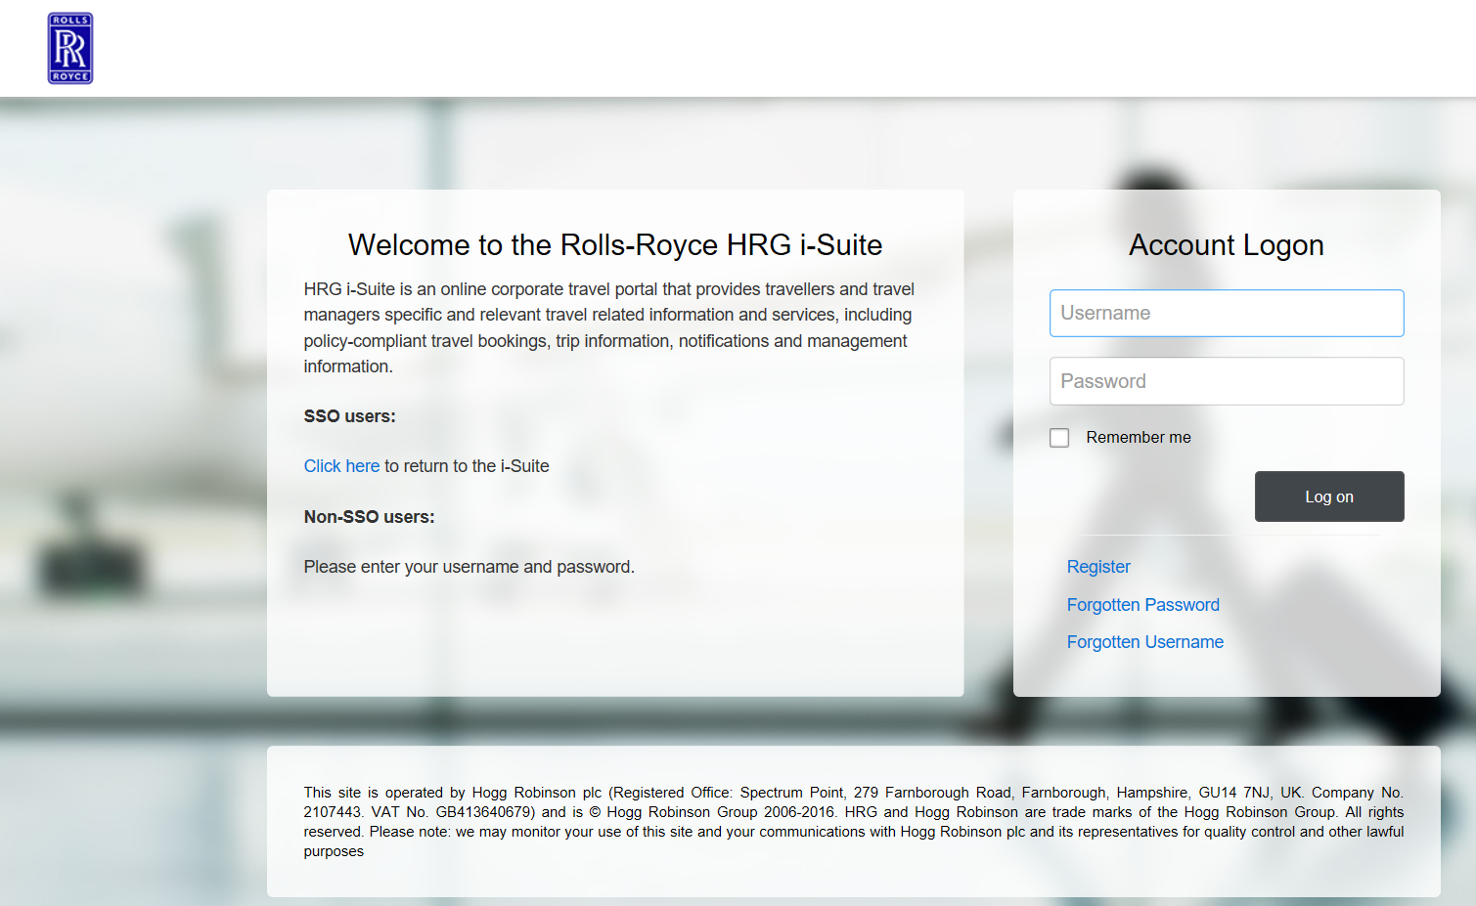

Click on Register

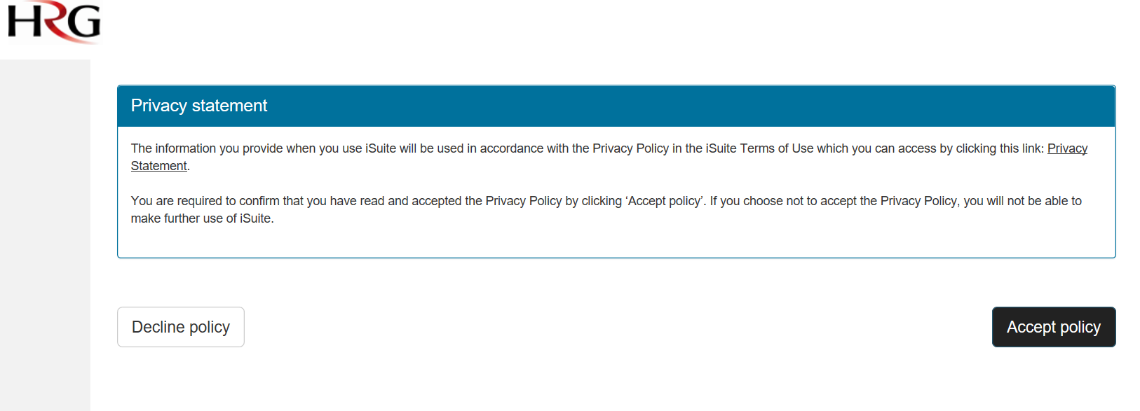

Click on Accept Policy

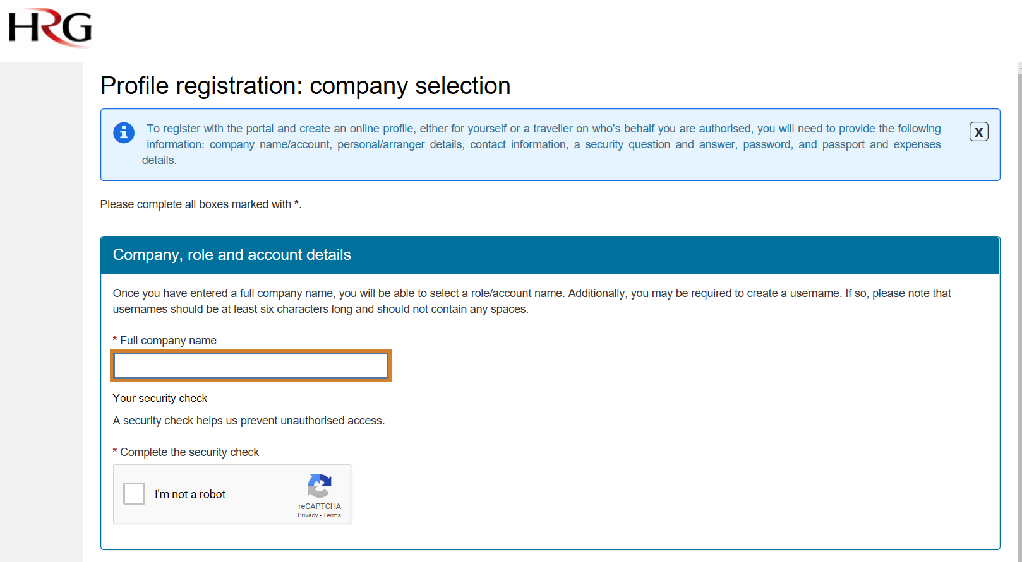

Type Rolls-Royce UK2 in the Full Company Name and check the I’m not a robot box and follow security check

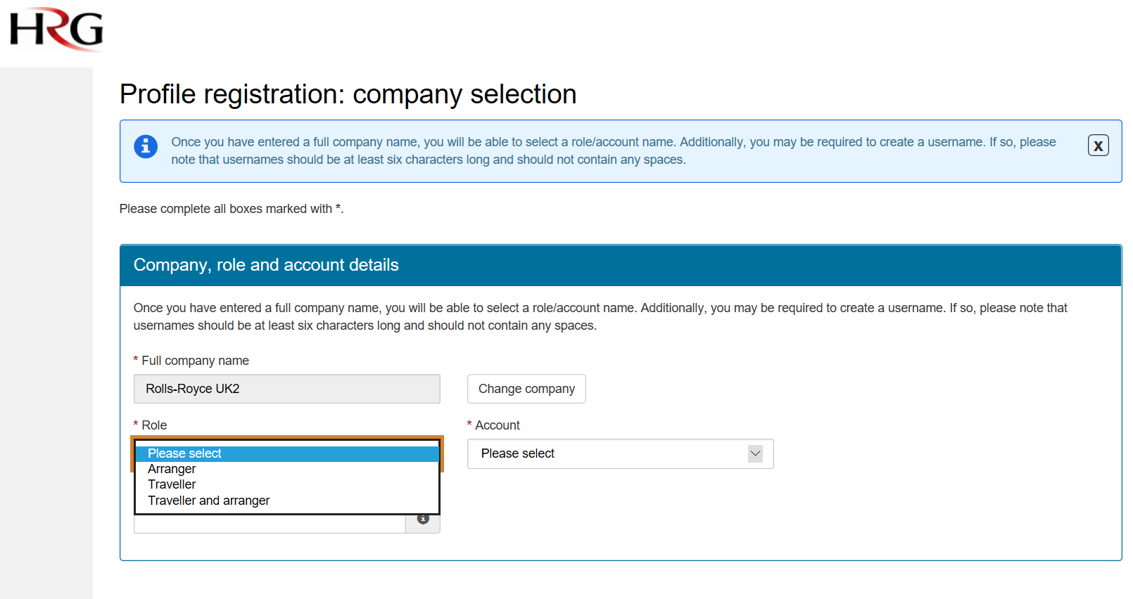

Select Role and under Account select RR Non-Employees

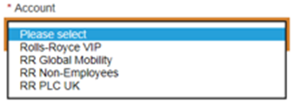

Your User Name needs to be either a RR email address or an email address that is registered as a regular contractor.

Complete the additional screens:

Password and Security Question / Personal Details / Passport / Company Address / Company Details

If you do not have a RR cost centre then please enter: NON EMP

If you do not have an RR Employee ID then please enter: 999999

On completing the application, you will then receive a link from Amex GBT to activate the profile. Please ensure you click on the link to activate. You can then update your profile with Travel Preferences, Membership Cards etc.

For support with building profiles Amex GBT contact details are:

Telephone: 0207 949 4921 Option 1

Email: gb.onlinesupport@amexgbt.com

For bookings Amex GBT contact details are:

Telephone: 0207 949 4921 Option 2

Email: GB.Travel@amexgbt.com

