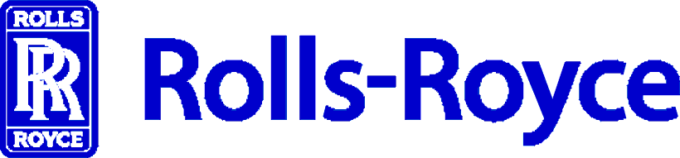
Please confirm your plans to attend the Rolls-Royce Supplier Release Process Training on any of the following dates scheduled in 2011 at the Learning and Development Center, Indianapolis, Indiana by returning this form electronically to:
Email contact: SuppQualCon@Rolls-Royce.com

To tick boxes please double click next to the box you wish to select and tick ‘checked’ in the default value section

For security reason, please check the box that is most applicable:

I am a Foreign National
I am a US citizen

To register your attendance, please complete all fields below:
*Quality manager must be signed up for training to successfully complete program.
Vendor Code: |  | Organization Name:
First Name
Last Name
Job Title
Email:
Phone:

Please choose one of the following dates:

- Wednesday, April 6 - Thursday, April 7, 2011 8:30 a.m. - 4:30 p.m.
- Wednesday, June 8 - Thursday, June 9, 2011 8:30 a.m. - 4:30 p.m.
- Wednesday, August 3 - Thursday, August 4, 2011 8:30 a.m. - 4:30 p.m.
- Wednesday, September 14 - Thursday, September 15, 2011 8:30 a.m. - 4:30 p.m.
- Wednesday, October 5 - Thursday, October 6, 2011 8:30 a.m. - 4:30 p.m.
- Wednesday, November 9 - Thursday, November 10, 2011 8:30 a.m. - 4:30 p.m.

Special Dietary Requirements
Please provide details of any special dietary requirements:

Ref: NTS308

